Experiment No. 1

A) Create a java class called **student** with the following details as variables within it.

1. USN
2. Name
3. Branch
4. Phone

Write a java program to create n student objects and print the USN, Name, Branch and Phone of these objects with suitable headings.

**Source code:**

import java.util.*;

public class student {

String USN;

String Name;

String Branch;

long Phone;

void insert(String usn, String name, String branch, long phone) {

this.USN = usn;

this.Name= name;

this.Branch = branch;

this.Phone = phone;

}

void display() {

System.out.println(USN + " " + Name + " " + Branch + " " + Phone);

}

public static void main(String[] args) {

student s[];

s = new student[100];

Scanner in = new Scanner(System.in);

System.out.print("Enter no of students: ");

int n = in.nextInt();

for(int i=0;i<n;i++){

s[i] = new student();

}

for(int i=0;i<n;i++) {

System.out.println("Enter details:");

System.out.print("Enter USN:");

String usn = in.next();

System.out.print("Enter Name:");

String name = in.next();

System.out.print("Enter Branch:");

String branch = in.next();

System.out.print("Enter Phone:");

long phone = in.nextLong();

s[i].insert(usn, name, branch, phone);

}

for(int i=0;i<n;i++) {

s[i].display();

System.out.println("");

}

}

}

**Output:**

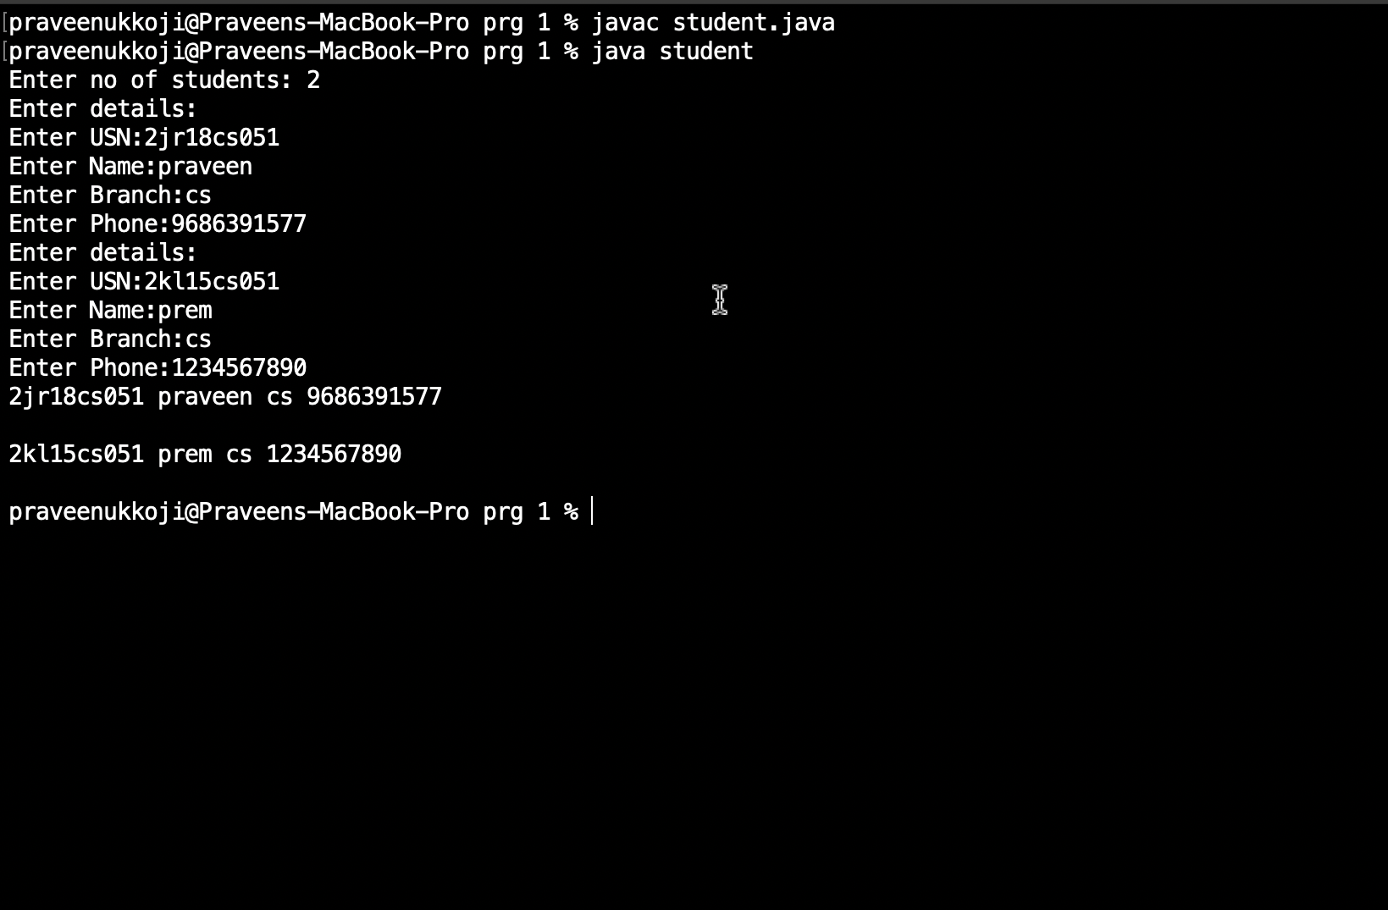

B) Write a java program to implement the stack using arrays. Write push(), pop() and display() methods to demonstrate its working.

**Source code:**

import java.util.*;

public class stack {

static int stack[], top = -1;

public static void main(String[] args) {

System.out.print("Enter Stack Size: ");

Scanner in = new Scanner(System.in);

int size = in.nextInt();

stack = new int[size];

System.out.println("\nOptions:\n1.PUSH\n2.POP\n3.DISPLAY\n4.EXIT");

System.out.print("Enter your Choice: ");

int choice = in.nextInt();

while(choice != 4)

{

if(choice == 1) {

System.out.print("\nEnter Element to push: ");

int element = in.nextInt();

if(top == size-1)

System.out.println("\nStack is full.");

else

stack[++top] = element;

}

else if(choice==2) {

if(top == -1)

System.out.println("\nStack is empty.");

else

System.out.println("\nPopped element is: "+ stack[top--]);

}

else if(choice==3) {

if(top == -1)

System.out.println("\nEmpty stack.");

else {

System.out.print("\nStack Elements are: ");

for(int i=top; i>=0 ;i--)

System.out.print(stack[i] + " ");

}

}

else

System.out.println("\nEnter Correct Choice \n");

System.out.println("\nOptions:\n1.PUSH\n2.POP\n3.DISPLAY\n4.EXIT");

System.out.print("Enter your Choice: ");

choice = in.nextInt();

}

in.close();

}

}

**Output:**

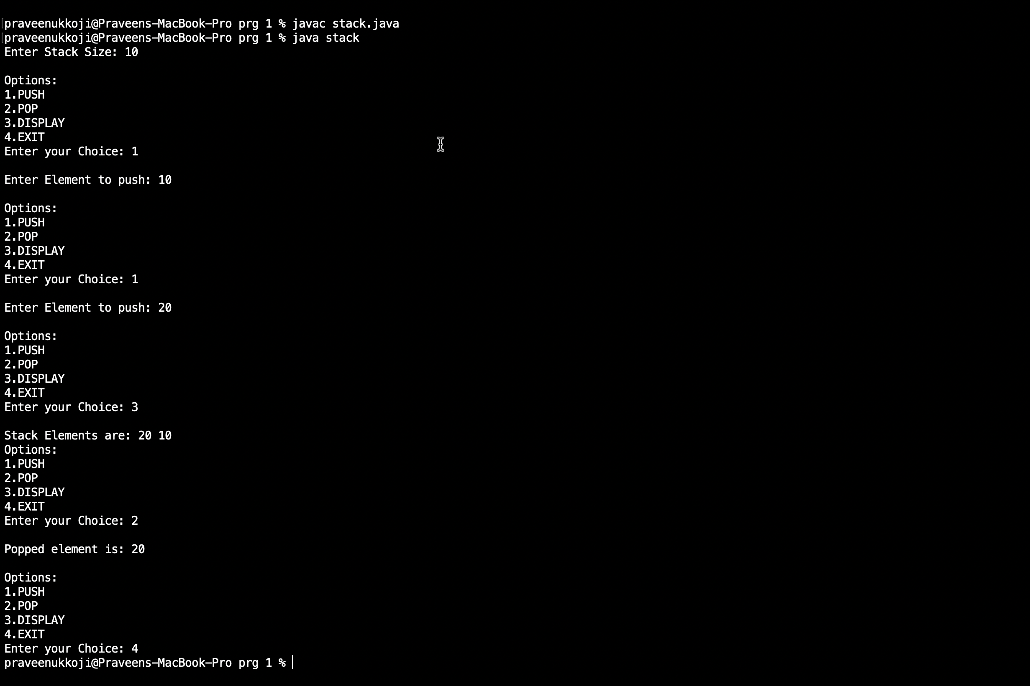

Experiment No. 2

A) Design a super class called **staff** with details as StaffId, Name, Phone, Salary.

Extend this class by writing three subclasses namely **Teaching**   
(domain, publications), **Technical** (skills) and **Contract** (period). Write a java program to read and display at least 3 staff objects of all three categoires.

**Source code:**

import java.util.*;

class Staff {

int StaffId;

String Phone;

int Salary;

String Name;

public Staff(int staffId, String phone, int salary, String name) {

this.StaffId = staffId;

this.Phone = phone;

this.Salary = salary;

this.Name = name;

}

void display() {

System.out.println("");

System.out.println("Staff Id: " + StaffId);

System.out.println("Phone: " + Phone);

System.out.println("Salary: " + Salary);

System.out.println("Name: " + Name);

}

}

class Teaching extends Staff {

String Domain;

int No_of_publications;

public Teaching(int staffId, String phone, int salary, String name, String domain, int no_of_publications) {

super(staffId, phone, salary, name);

this.Domain = domain;

this.No_of_publications = no_of_publications;

}

void TeachingDisplay() {

System.out.println("");

System.out.println("Teaching Staff Details:");

super.display();

System.out.println("Domain: " + Domain);

System.out.println("No_of_publications: " + No_of_publications);

}

}

class Technical extends Staff {

String Skills;

public Technical(int staffId, String phone, int salary, String name, String skill) {

super(staffId, phone, salary, name);

this.Skills = skill;

}

void TechnicalDisplay() {

System.out.println("");

System.out.println("Technical Staff Details:");

super.display();

System.out.println("Skills: " + Skills);

}

}

class Contract extends Staff {

int Period;

public Contract(int staffId, String phone, int salary, String name, int period) {

super(staffId, phone, salary, name);

this.Period = period;

}

void ContractDisplay() {

System.out.println("");

System.out.println("Contract Staff Details:");

super.display();

System.out.println("Period: " + Period + " years");

}

}

public class main_staff {

public static void main(String[] args) {

Teaching Te1 = new Teaching(11, "9987654341", 300000, "Praveen", "Cse", 10);

Teaching Te2 = new Teaching(12, "9987654341", 31500, "Pavya", "Mech", 11);

Teaching Te3 = new Teaching(13, "9987654341", 3000, "Pravin", "EE", 12);

Te1.TeachingDisplay();

Te2.TeachingDisplay();

Te3.TeachingDisplay();

Technical Tn1 = new Technical(11, "9987654341", 22000, "Pavya", "C");

Technical Tn2 = new Technical(12, "9987654341", 23000, "Pavya2", "java");

Technical Tn3 = new Technical(13, "9987654341", 23000, "Pavya3", "C++");

Tn1.TechnicalDisplay();

Tn2.TechnicalDisplay();

Tn3.TechnicalDisplay();

Contract C1 = new Contract(11, "9987654341", 35000, "Pavya1", 3);

Contract C2 = new Contract(12, "9987654341", 36000, "Pavya2", 2);

Contract C3 = new Contract(13, "9987654341", 37000, "Pavya3", 1);

C1.ContractDisplay();

C2.ContractDisplay();

C3.ContractDisplay();

}

}

**Output:**

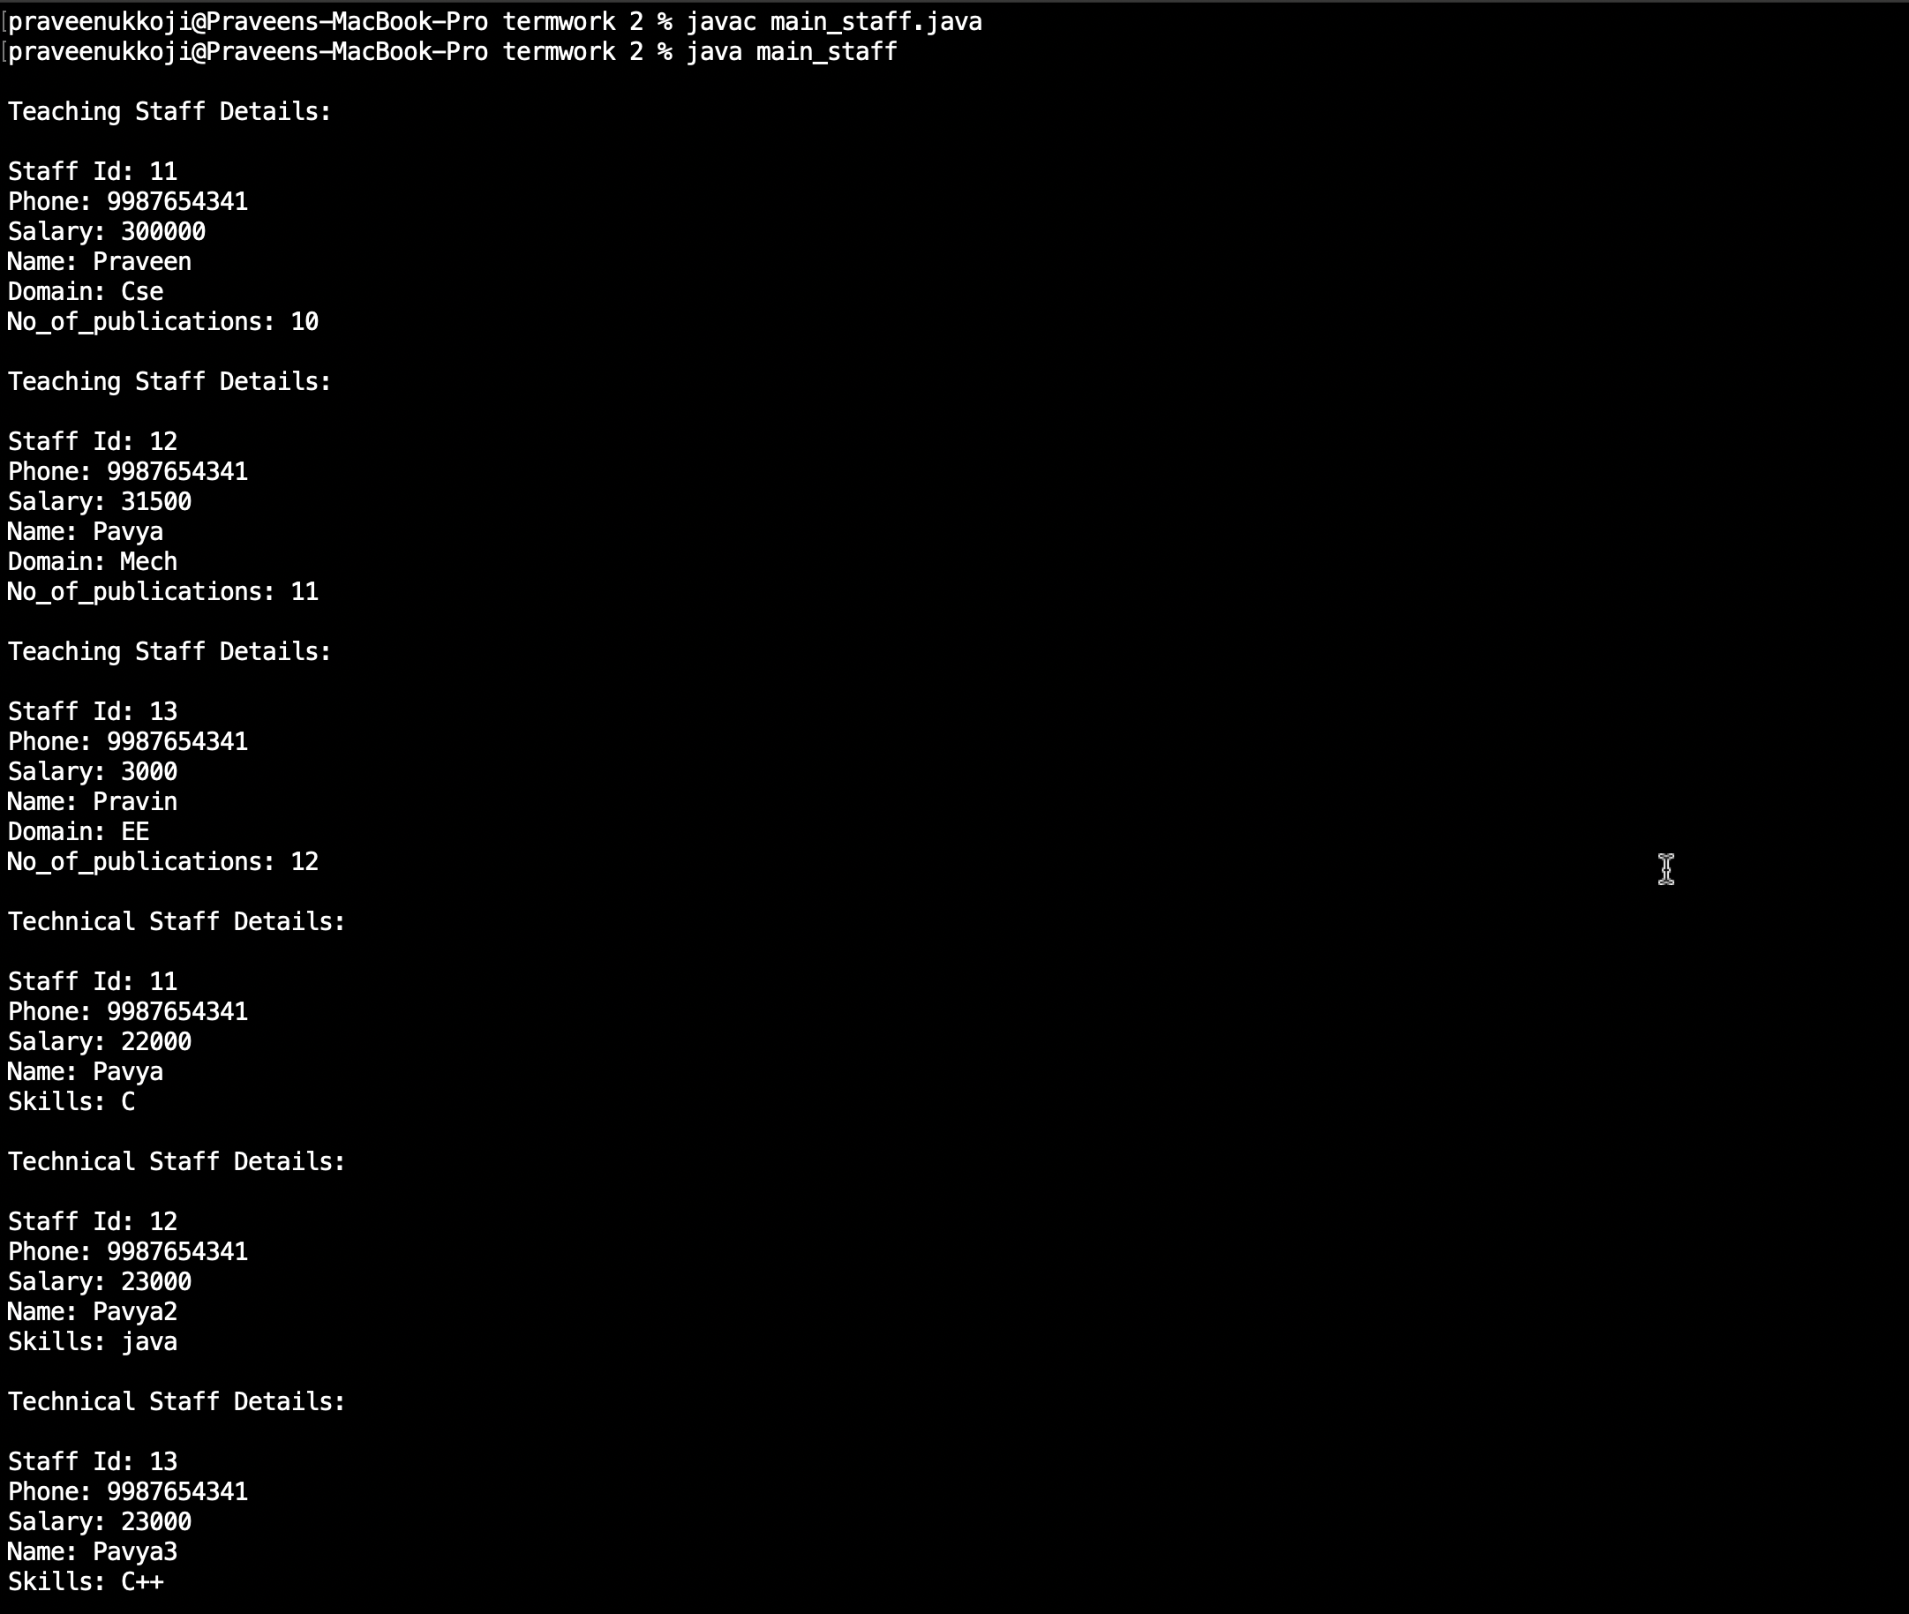

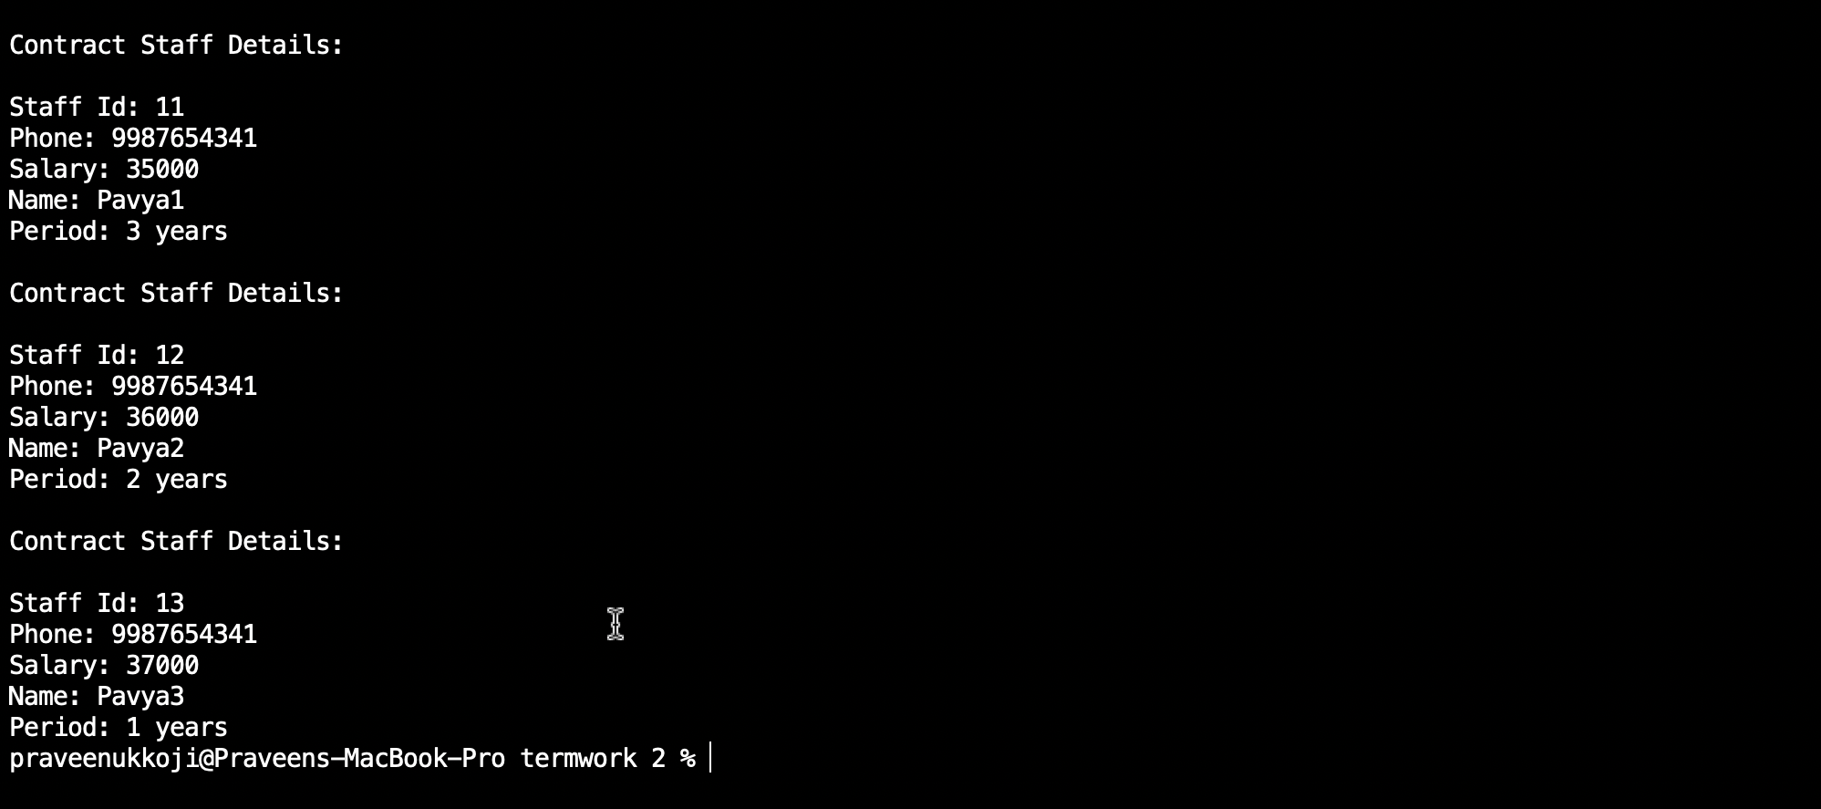

B) Write a java class called **Customer** to store their name and date_of_birth. The date_of_birth format should be dd/mm/yyyy. Write methods to read customer data as < name, dd/mm/yyy > and display < name, dd, mm, yyyy > using StringTokenizer class considering the delimete character as “/”.

**Source code:**

import java.util.Scanner;

import java.util.StringTokenizer;

public class customer {

String Name ;

String Date;

String Month;

String Year;

void read() {

Scanner in = new Scanner(System.in);

System.out.println("\nEnter Name and DOB in Name, DD/MM/YYYY Format: ");

String str = in.next();

StringTokenizer st = new StringTokenizer(str, "," + "/");

this.Name=st.nextToken();

this.Date=st.nextToken();

this.Month=st.nextToken();

this.Year=st.nextToken();

this.Name=this.Name.trim();

this.Date=this.Date.trim();

this.Month=this.Month.trim();

this.Year=this.Year.trim();

in.close();

}

void display() {

System.out.println("\nCustomer Details is: ");

System.out.println(this.Name + "," + this.Date + "," + this.Month + "," + this.Year);

}

public static void main(String[] args) {

customer c1 = new customer();

c1.read();

c1.display();

}

}

**Output:**

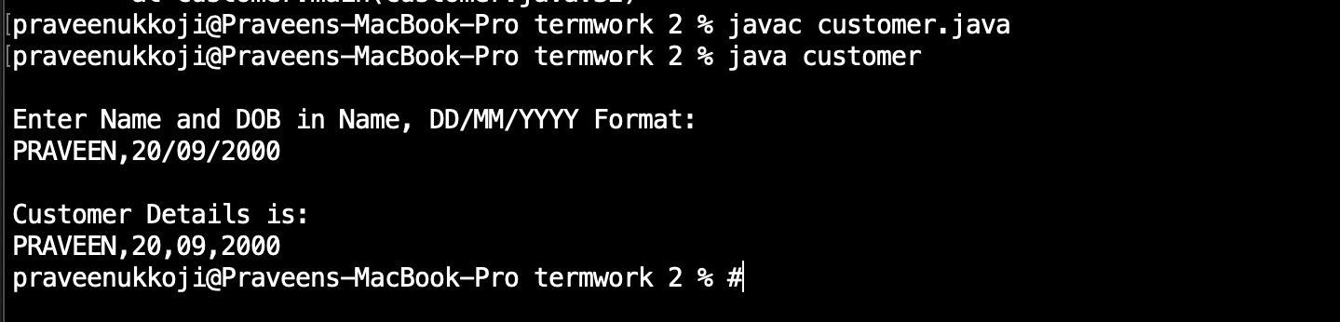

Experiment No. 3

A) Write a java program to read two integers a and b. Compute a/b and print, when b is not zero. Raise an excepetion when b is equal to zero.

**Source code:**

import java.util.Scanner;

public class Excep {

public static void main(String[] args) {

Scanner in = new Scanner(System.in);

int a,b,c;

System.out.println("Enter val of a and b: ");

a = in.nextInt();

b = in.nextInt();

try {

c = a/b;

System.out.println("c = " + c);

}catch(ArithmeticException e) {

System.out.println("Exception Encountered is "+ e);

}

in.close();

}

}

**Output :**

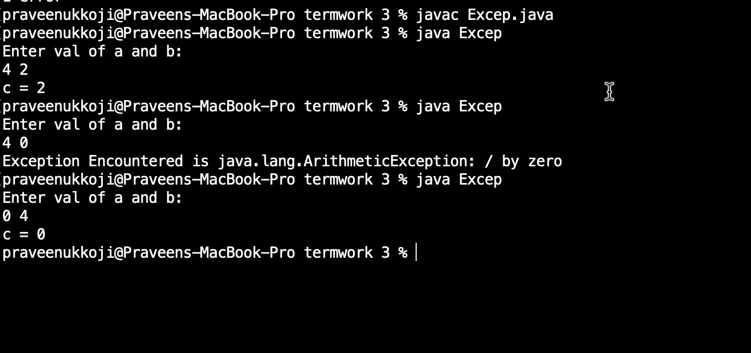

B) Write a java program that implements a multi-thread application that has three threads. First thread generates a random integer for every one second, second thread computes the square of the number and prints, third will print the value of cube of the number.

**Source code :**

import java.util.*;

class second implements Runnable

{

public int x;

public second (int x)

{

this.x=x;

}

public void run()

{

System.out.println("Second thread : Square of the number is: " + x * x);

}

}

class third implements Runnable

{

public int x;

public third(int x)

{

this.x=x;

}

public void run()

{

System.out.println("third thread : Cube of the number is: " + x * x * x);

System.out.println("");

}

}

class first extends Thread

{

public void run()

{

int num=0;

Random r=new Random();

try

{

for(int i=0;i<5;i++)

{

num=r.nextInt(100);

System.out.println("first thread generated number is: " + num);

Thread t2=new Thread (new second(num));

t2.start();

Thread t3=new Thread(new third(num));

t3.start();

Thread.sleep(1000);

}

}

catch(Exception e)

{

System.out.println(e.getMessage());

}

}

}

public class prg3b

{

public static void main(String args[])

{

first a=new first();

a.start();

}

}

**Output :**

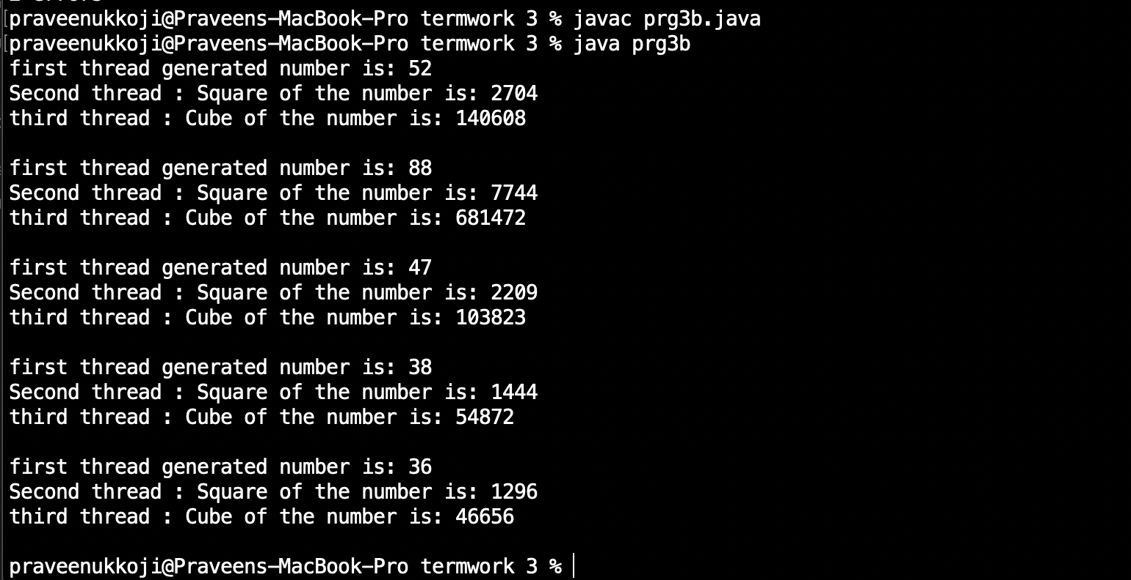

**Experiment No. 4**

Sort a given set of n integers elements using Quicksort method and compute its time complexity. Run the program for varied values of n>5000 and record the time taken to sort. Plot a graph of the time taken v/s n on graph sheet. The elements can be read from a file or can be generated using the random number generator. Demonstrate using java how the divide-and-conquer methods works along with its time complexity analysis worst case, average case and best case.

**Source code :**

import java.util.Scanner;

public class quick {

static int a[];

static void qsort(int left, int right)

{

if(left<right)

{

int p = partition(left, right);

qsort(left, p-1);

qsort(p+1, right);

}

}

static int partition(int low, int high)

{

int pivot = a[high];

int pindex=low;

for(int i=low;i<=high-1;i++)

{

if(a[i]<=pivot)

{

int temp = a[pindex];

a[pindex] = a[i];

a[i] = temp;

pindex++;

}

}

int temp = a[pindex];

a[pindex] = a[high];

a[high] = temp;

return pindex;

}

public static void main(String[] args) {

Scanner s = new Scanner(System.in);

int n, i;

System.out.println("Enter the no. of elements: ");

n = s.nextInt();

a = new int[n];

System.out.println("The Random Numbers are:");

for (i = 0; i < n; i++)

{

a[i] = (int) (Math.random() * 100);

System.out.print(a[i]+" ");

}

long startTime = System.nanoTime();

qsort(0, n-1);

long endTime = System.nanoTime();

long duration = (endTime - startTime);

System.out.println("\nThe Sorted Numbers are: ");

for (i = 0; i < n; i++) {

System.out.print(a[i] +" ");

}

System.out.println("\nTime taken is: "+ duration/1000 + " microseconds" );

}

}

**Output :**

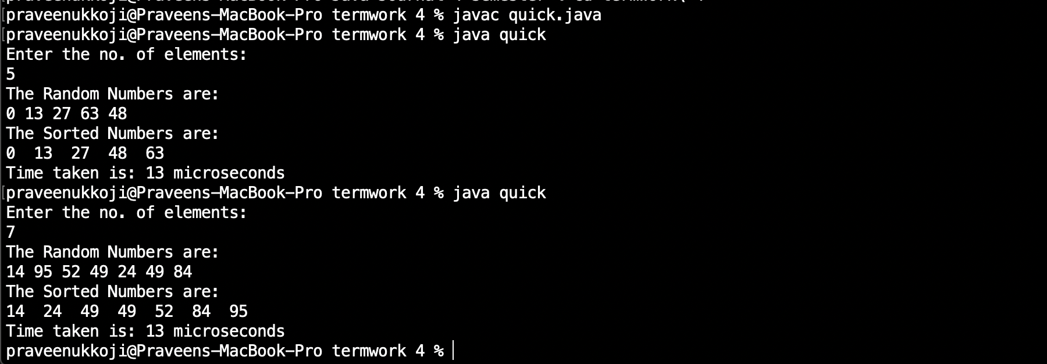

**Experiment No. 5**

Sort a given set of n integers elements using Mergesort method and compute its time complexity. Run the program for varied values of n>5000 and record the time taken to sort. Plot a graph of the time taken v/s n on graph sheet. The elements can be read from a file or can be generated using the random number generator. Demonstrate using java how the divide-and-conquer methods works along with its time complexity analysis worst case, average case and best case.

**Source code :**

import java.util.Random;

import java.util.Scanner;

public class mergesort{

static int max=10000;

void merge( int[] array,int low, int mid,int high)

{

int i=low;

int j=mid+1;

int k=low;

int[]resarray;

resarray=new int[max];

while(i<=mid&&j<=high)

{

if(array[i]<array[j])

{

resarray[k]=array[i];

i++;

k++;

}

else

{

resarray[k]=array[j];

j++;

k++;

}

}

while(i<=mid)

resarray[k++]=array[i++];

while(j<=high)

resarray[k++]=array[j++];

for(int m=low;m<=high;m++)

array[m]=resarray[m];

}

void sort( int[] array,int low,int high)

{

if(low<high)

{

int mid=(low+high)/2;

sort(array,low,mid);

sort(array,mid+1,high);

merge(array,low,mid,high);

}

}

public static void main(String[] args) {

int[] array;

int i;

System.out.println("Enter the array size");

Scanner sc =new Scanner(System.in);

int n=sc.nextInt();

array= new int[max];

Random generator=new Random();

for( i=0;i<n;i++)

array[i]=generator.nextInt(20);

System.out.println("Array before sorting: ");

for( i=0;i<n;i++)

System.out.print(array[i]+" ");

System.out.println("");

long startTime=System.nanoTime();

mergesort m=new mergesort();

m.sort(array,0,n-1);

long stopTime=System.nanoTime();

long elapseTime=(stopTime-startTime);

System.out.println("Time taken to sort array is: "+elapseTime+" nano seconds.");

System.out.println("Sorted array is");

for( i=0;i<n;i++)

System.out.print(array[i]+" ");

System.out.println("");

}

}

**Output :**

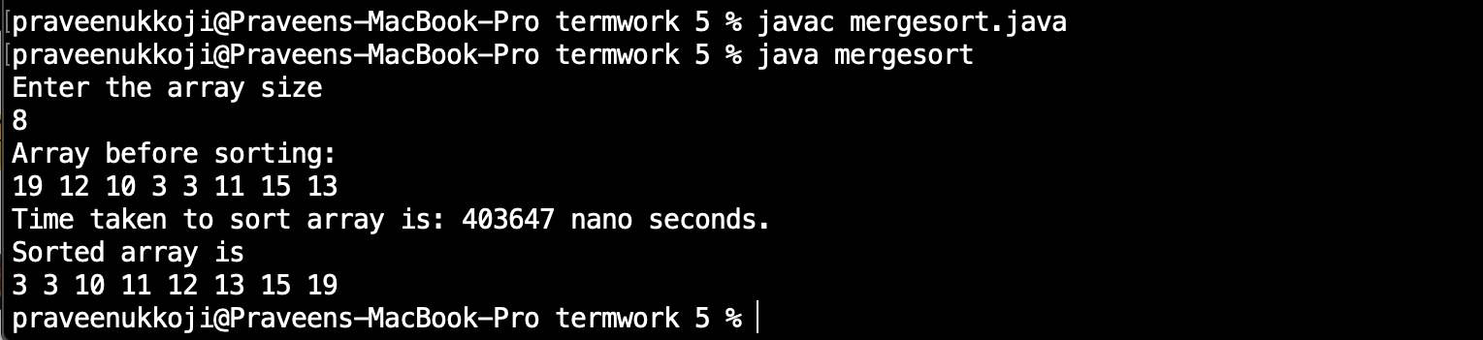

**Experiment No. 6**

Implement in JAVA, the 0/1 knapsack problem using

A) Dynamic programming method.

**Source code:**

import java.util.Scanner;

public class knapsackDP {

public void solve(int[] wt, int[] val, int W, int N)

{

int i,j;

int[][] sol = new int[N + 1][W + 1];

for ( i = 0; i <= N; i++){

for ( j = 0; j <= W; j++)

{

if(i==0||j==0)

sol[i][j]=0;

else if(wt[i]>j)

sol[i][j]=sol[i-1][j];

else

sol[i][j]=Math.max((sol[i-1][j]), (sol[i - 1][j - wt[i]] + val[i]));

}

}

System.out.println("The optimal solutionis: "+ sol[N][W]);

int[] selected = new int[N + 1];

for(i=0;i<N+1;i++)

selected[i]=0;

i=N;

j=W;

while (i>0&&j>0){

if (sol[i][j] !=sol[i-1][j]){

selected[i] = 1;

j = j - wt[i];

}

i--;

}

System.out.print("\nItems selected : ");

for ( i = 1; i < N + 1; i++)

if (selected[i] == 1)

System.out.println(i + " ");

}

public static void main(String[] args) {

Scanner scan = new Scanner(System.in);

knapsackDP ks = new knapsackDP();

System.out.println("Enter number of elements ");

int n = scan.nextInt();

int[] wt = new int[n + 1];

int[] val = new int[n + 1];

System.out.println("\nEnter weight for "+ n +" elements");

for (int i = 1; i <= n; i++)

wt[i] = scan.nextInt();

System.out.println("\nEnter value for "+ n +" elements");

for (int i = 1; i <= n; i++)

val[i] = scan.nextInt();

System.out.println("\nEnter knapsack weight ");

int W = scan.nextInt();

System.out.println("\n");

ks.solve(wt, val, W, n);

}

}

**Output:**

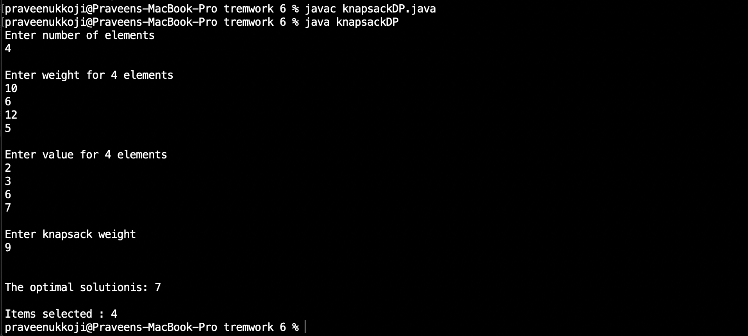

B) Greedy programming method.

**Source code:**

import java.util.Scanner;

public class knapsackGD {

static int size=1000,n,j;

static float max,sum=0;

void knap(int W,int wei[],int val[]) {

while(W>=0){

max=0;

for(int i=0;i<n;i++) {

if((float)val[i]/(float) wei[i]>max){

max=((float)val[i]/(float)wei[i]);

j=i;

}

}

if(wei[j]>W){

System.out.println("Weight added to knapsack "+W);

sum+=W*max;

W=-1;

}

else{

System.out.println("Weigth added to knapsack "+wei[j]);

sum+=(float)val[j];

W=W-wei[j];

val[j]=0;

}

}

System.out.println("The Maximum Value/Profit is "+sum );

}

public static void main(String[] args) {

System.out.println("-------Knapsack Problem ------");

System.out.println("Enter weight of knapsack ");

Scanner sc = new Scanner(System.in);

int W=sc.nextInt();

int w[]=new int[size];

int v[]=new int[size];

System.out.println("Enter number of items ");

n=sc.nextInt();

System.out.println("Enter Weights "+n+" Respective Items");

for(int i=0;i<n;i++) {

w[i]=sc.nextInt();

}

System.out.println("Enter value of "+n+" Item ");

for(int i=0;i<n;i++) {

v[i]=sc.nextInt();

}

knapsackGD k = new knapsackGD();

k.knap(W,w,v);

sc.close();

}

}

**Output:**

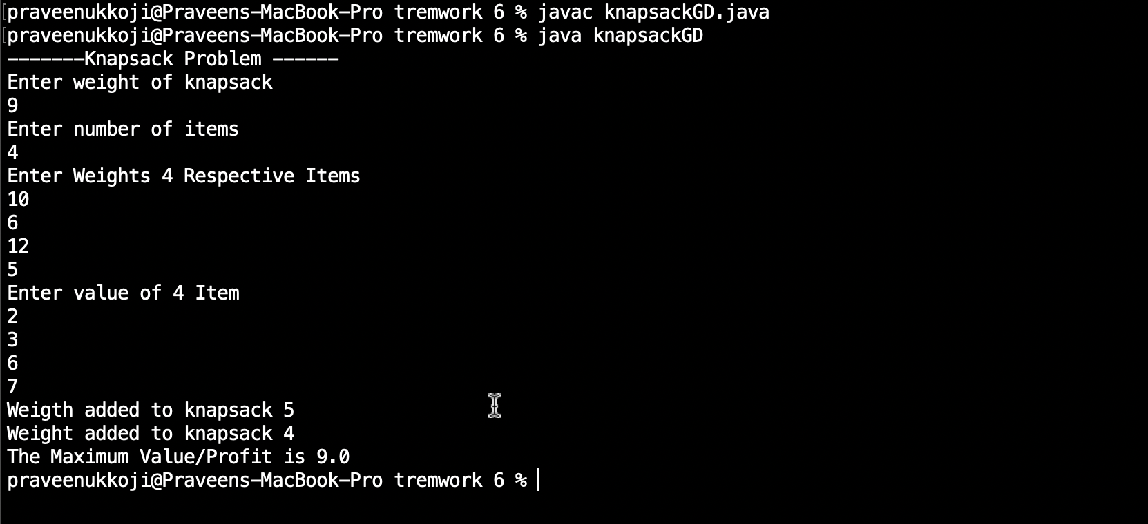

**Experiment No. 7**

From a given vertex in a weighted connected graph, find shortest paths to other vertices using **Dijkstra’s algorithm**. Write the program in java.

**Source code:**

import java.util.Scanner;

public class Dijkstra {

int d[]=new int[10]; int p[]=new int[10];

int visited[]=new int[10];

public void dijk(int[][]a, int s, int n)

{

int u=-1,v,i,j,min;

for(v=0;v<n;v++)

{

d[v]=99;

p[v]=-1;

}

d[s]=0;

for(i=0;i<n;i++)

{

min=99;

for(j=0;j<n;j++)

{

if(d[j]<min&& visited[j]==0)

{

min=d[j]; u=j;

}

}

visited[u]=1;

for(v=0;v<n;v++){

if((d[u]+a[u][v]<d[v])&&(u!=v)&&visited[v]==0)

{

d[v]=d[u]+a[u][v]; p[v]=u;

}

}

}

}

void path(int v,int s)

{

if(p[v]!=-1)

path(p[v],s);

if(v!=s)

System.out.print("->"+v+" ");

}

void display(int s,int n)

{

int i;

for(i=0;i<n;i++)

{

if(i!=s){

System.out.print(s+" "); path(i,s);

}

if(i!=s)

System.out.print("="+d[i]+" "); System.out.println();

}

}

public static void main(String[] args) {

int a[][]=new int[10][10]; int i,j,n,s;

System.out.println("enter the number of vertices");

Scanner sc = new Scanner(System.in);

n=sc.nextInt();

System.out.println("enter the weighted matrix");

for(i=0;i<n;i++) for(j=0;j<n;j++)

a[i][j]=sc.nextInt();

System.out.println("enter the source vertex");

s=sc.nextInt();

Dijkstra tr=new Dijkstra();

tr.dijk(a,s,n);

System.out.println("the shortest path between source"+s+"to remaining vertices are");

tr.display(s,n);

sc.close();

}

}

**Output:**

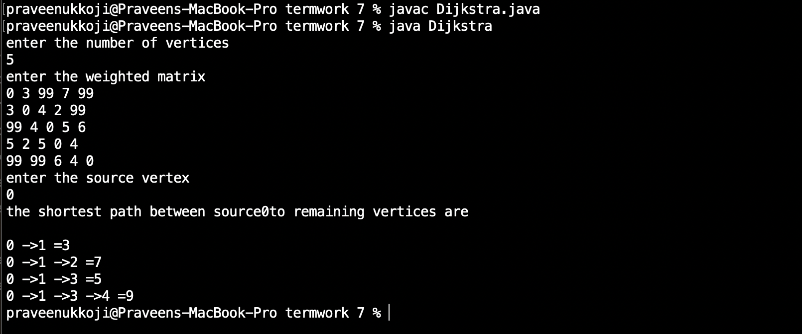

**Experiment No. 8**

Find Minimum Cost Spanning Tree of a given undirected graph using

A) **Kruskal’s** Algorithm

B) **Prim’s** Algorithm

Implement the program in Java language.

A) Kruskal’s Algorithm

**Source code:**

import java.util.Scanner;

public class kruskals {

int parent[]=new int[10];

int find(int m)

{

int p=m;

while(parent[p]!=0)

p=parent[p];

return p;

}

void union(int i,int j)

{

if(i<j)

parent[i]=j;

else

parent[j]=i;

}

void krkl(int[][]a, int n)

{

int u=0,v=0,min,k=0,i,j,sum=0;

while(k<n-1)

{

min=99;

for(i=1;i<=n;i++)

for(j=1;j<=n;j++)

if(a[i][j]<min&&i!=j)

{

min=a[i][j];

u=i;

v=j;

}

i=find(u);

j=find(v);

if(i!=j)

{

union(i,j);

System.out.println("("+u+","+v+")"+"="+a[u][v]);

sum=sum+a[u][v];

k++;

}

a[u][v]=a[v][u]=99;

}

System.out.println("The cost of minimum spanning tree = "+sum);

}

public static void main(String[] args) {

int a[][]=new int[10][10];

int i,j;

System.out.println("Enter the number of vertices of the graph");

Scanner sc=new Scanner(System.in);

int n;

n=sc.nextInt();

System.out.println("Enter the wieghted matrix");

for(i=1;i<=n;i++)

for(j=1;j<=n;j++)

a[i][j]=sc.nextInt();

kruskals k=new kruskals();

k.krkl(a,n);

sc.close();

}

}

**Output:**

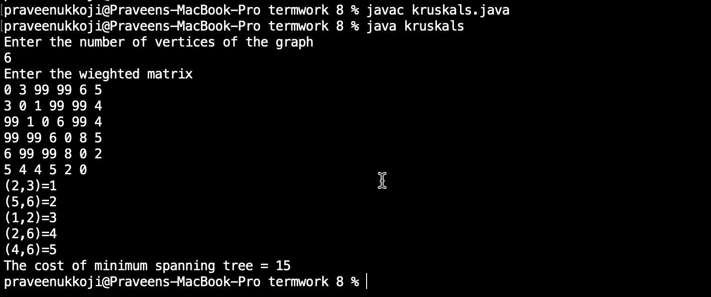

B) Prim’s Algorithm

**Source code:**

import java.util.Scanner;

public class prims {

public static void main(String[] args) {

int n=100;

int size,i,j;

int u=0,v=0;

int sum=0;

Scanner sc = new Scanner(System.in);

System.out.println("Enter Size of Matrix ");

size=sc.nextInt();

int a[][] =new int[n][n];

int visited[] = new int[n];

System.out.println("Enter the Adjacency matrix ");

for(i=1;i<=size;i++) {

for(j=1;j<=size;j++) {

a[i][j]=sc.nextInt();

}

}

for(i=1;i<=size;i++){

visited[i]=0;

}

System.out.println("Enter the Source ");

int source=sc.nextInt();

visited[source]=1;

int counter=1;

while(counter<=size) {

int mini=99;

for(int p=1;p<=size;p++) {

for(int q=1;q<=size;q++) {

if(visited[p]==1 && visited[q]==0) {

if(p!=q && a[p][q]<mini)

{

mini=a[p][q];

u=p;

v=q;

}

}

}

}

visited[v]=1;

counter++;

if(mini!=99) {

System.out.println(u+"--->"+v+" = "+mini);

sum=sum+mini;

}

}

System.out.println("Minimum Spanning Tree "+sum);

sc.close();

}

}

**Output:**

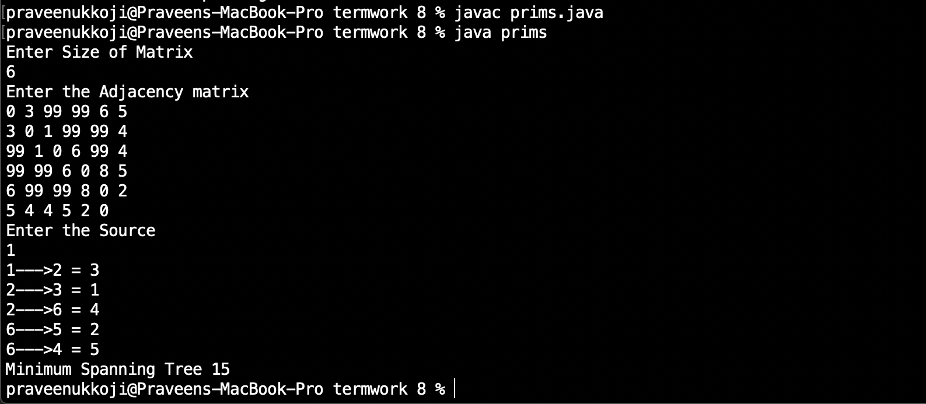

**Experiment No. 9**

Write java programs to

A) Implement all pair shortest path problem using **Floyd’s** algorithm

B) Implement **Travelling Sales person** problem using dynamic programming

A) Floyd’s algorithm

**Source code:**

import java.util.Scanner;

public class floyd {

void flyd(int[][] w,int n) {

int i,j,k;

for(k=1;k<=n;k++)

for(i=1;i<=n;i++)

for(j=1;j<=n;j++)

w[i][j]=Math.min(w[i][j],w[i][k]+w[k][j]);

}

public static void main(String[] args) {

int a[][]=new int [10][10];

int n,i,j;

System.out.println("Enter number of vertices ");

Scanner sc = new Scanner(System.in);

n=sc.nextInt();

System.out.println("Enter the weighted matrix ");

for(i=1;i<=n;i++)

for(j=1;j<=n;j++)

a[i][j]=sc.nextInt();

floyd f = new floyd();

f.flyd(a, n);

System.out.println("Shortest Path ");

for(i=1;i<=n;i++)

{

for(j=1;j<=n;j++)

System.out.print(a[i][j] + " ");

System.out.println();

}

sc.close();

}

}

**Output:**

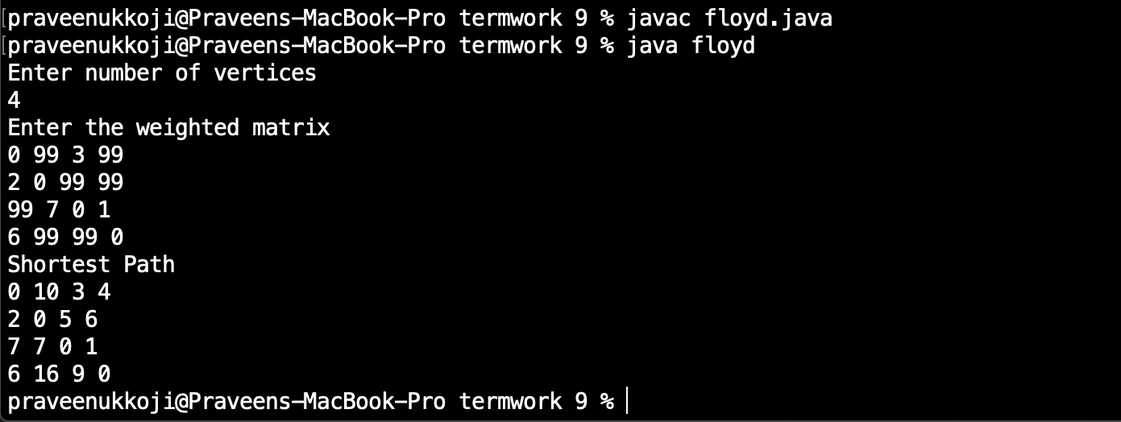

B) Travelling Sales person problem

**Source code:**

import java.util.Scanner;

class Travel {

int weight[][],n,tour[],finalCost;

final int INF=1000;

Travel()

{

Scanner s=new Scanner(System.in);

System.out.println("Enter no. of nodes:=>");

n=s.nextInt();

weight=new int[n][n];

tour=new int[n-1];

System.out.println("Enter Adjacency Matrix ");

for(int i=0;i<n;i++)

for(int j=0;j<n;j++)

weight[i][j]=s.nextInt();

System.out.println();

System.out.println("Starting node assumed to be node 1.");

eval();

s.close();

}

public int COST(int curr,int inputSet[],int setSize)

{

if(setSize==0)

return weight[curr][0];

int min=INF;

int setNextCOST[]=new int[n-1];

for(int i=0;i<setSize;i++)

{

int k=0;

for(int j=0;j<setSize;j++)

{

if(inputSet[i]!=inputSet[j])

setNextCOST[k++]=inputSet[j];

}

int temp=COST(inputSet[i],setNextCOST,setSize-1);

if((weight[curr][inputSet[i]]+temp) < min)

{

min=weight[curr][inputSet[i]]+temp;

}

}

return min;

}

public int MIN(int current,int inputSet[],int setSize)

{

if(setSize==0)

return weight[current][0];

int min=INF,minindex=0;

int setNextCOST[]=new int[n-1];

for(int i=0;i<setSize;i++)//considers each node of inputSet

{

int k=0;

for(int j=0;j<setSize;j++)

{

if(inputSet[i]!=inputSet[j])

setNextCOST[k++]=inputSet[j];

}

int temp=COST(inputSet[i],setNextCOST,setSize-1);

if((weight[current][inputSet[i]]+temp) < min)

{

min=weight[current][inputSet[i]]+temp;

minindex=inputSet[i];

}

}

return minindex;

}

public void eval()

{

int dummySet[]=new int[n-1];

for(int i=1;i<n;i++)

dummySet[i-1]=i;

finalCost=COST(0,dummySet,n-1);

constructTour();

}

public void constructTour()

{

int previousSet[]=new int[n-1];

int nextSet[]=new int[n-2];

for(int i=1;i<n;i++)

previousSet[i-1]=i;

int setSize=n-1;

tour[0]=MIN(0,previousSet,setSize);

for(int i=1;i<n-1;i++)

{

int k=0;

for(int j=0;j<setSize;j++)

{

if(tour[i-1]!=previousSet[j])

nextSet[k++]=previousSet[j];

}

--setSize;

tour[i]=MIN(tour[i-1],nextSet,setSize);

for(int j=0;j<setSize;j++)

previousSet[j]=nextSet[j];

}

display();

}

public void display()

{

System.out.println();

System.out.print("The tour is 1-");

for(int i=0;i<n-1;i++)

System.out.print((tour[i]+1)+"-");

System.out.print("1");

System.out.println();

System.out.println("The final cost is "+finalCost);

}

}

class TravellingSalesman

{

public static void main(String args[])

{

Travel obj=new Travel();

obj.eval();

}

}

**Output:**

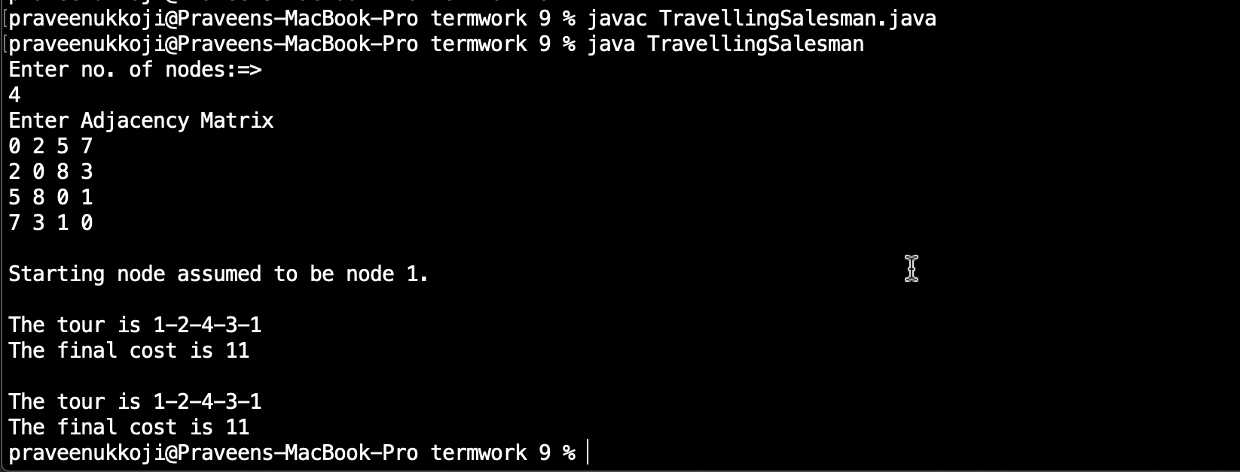

**Experiment No. 10**

Write java programs to

A) Design and implement in java to find a subset of a given set S = {s1, s2, …} of n positive integers whose SUM is equal to a given positive integer d. for example, if S = {1, 2, 5, 6, 8} and d = 9, there are two solutions {1, 2, 6} and {1, 8}. Display a suitable message, if the given problem instance doesn’t have a solution.

**Source code:**

import java.util.Scanner;

import java.lang.Math;

public class Subset {

static int x[]=new int[100];

public void subset(int num, int n) {

for(int i=1;i<=n;i++)

x[i]=0;

for(int i=n;num!=0;i--) {

x[i]=num%2;

num/=2;

}

}

public static void main(String[] args) {

int n,d,sum,j,flag=0;

int a[]=new int[100];

Scanner sc=new Scanner(System.in);

System.out.println("Enter number of elements ");

n=sc.nextInt();

System.out.println("Enter the elements ");

for(int i=1;i<=n;i++)

a[i]=sc.nextInt();

System.out.println("Enter val of d ");

d=sc.nextInt();

if(d>0) {

for(int i=1;i<=Math.pow(2,n)-1;i++) {

Subset s=new Subset();

s.subset(i,n);

sum=0;

for(j=1;j<=n;j++) {

if(x[j]==1)

sum+=a[j];

}

if(d == sum) {

flag=1;

System.out.print("Subset is { ");

for(j=1;j<=n;j++)

{

if(x[j]==1)

System.out.print(a[j]+" ");

}

System.out.print("} == "+sum);

System.out.println();

}

}

if(flag == 0)

System.out.println("No Answer");

sc.close();

}

}

}

**Output:**

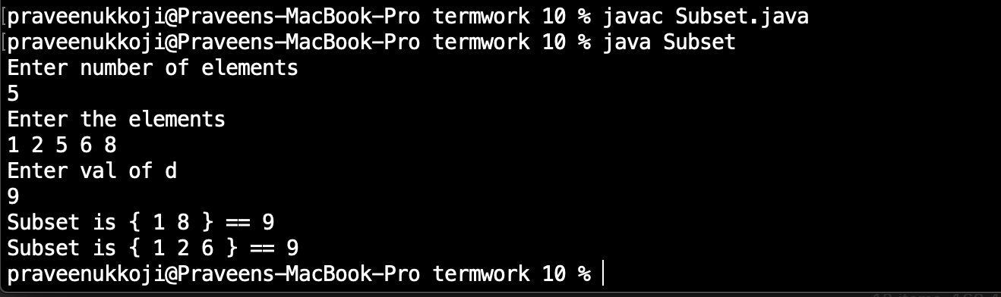

B) Design and implement the presence of **Hamiltonian Cycle** in an undirected Graph G of n vertices.

**Source code:**

import java.util.*;

class Ham

{

private int mat[][],x[],n;

public Ham()

{

Scanner sc = new Scanner(System.in);

System.out.println("Enter the number of nodes");

n=sc.nextInt();

x=new int[n];

x[0]=0;

for (int i=1;i<n; i++)

x[i]=-1;

mat=new int[n][n];

System.out.println("Enter the matacency matrix");

for (int i=0;i<n; i++)

for (int j=0; j<n; j++)

mat[i][j]=sc.nextInt();

sc.close();

}

public void nextValue (int v)

{

int i=0;

while(true)

{

x[v]=x[v]+1;

if (x[v]==n)

x[v]=-1;

if (x[v]==-1)

return;

if (mat[x[v-1]][x[v]]==1)

for (i=0; i<v; i++)

if (x[i]==x[v])

break;

if (i==v)

if (v<n-1 || v==n-1 && mat[x[n-1]][0]==1)

return;

}

}

public void getCycle(int v)

{

while(true)

{

nextValue(v);

if (x[v]==-1)

return;

if (v==n-1)

{

System.out.println("\nSolution : ");

for (int i=0; i<n; i++)

System.out.print((x[i]+1)+" ");

System.out.println(1);

}

else getCycle(v+1);

}

}

}

class Hamilton

{

public static void main(String args[])

{

Ham obj=new Ham();

obj.getCycle(1);

}

}

**Output:**

